-->

OK, this is a very common blog post and you might probably find dozens of related posts, but going along with the promise that I shall share what I shall learn, I am going to tell about a method which shall allow you to exercise control over the writing permissions to a USB device. This method applies to computers above windows XP.

Well, I am in a new place and here, they gave me a computer to work on. Fortunately, they had to give me an admin account, because my work demanded the use of some software with hardware keys. But I found that I could not take my workspace home, because writing into a USB storage device had been forbidden. So I fished the internet and found this method to get rid of this constant bugging. Here is how I did it.

*\*Note: Don’t forget to export your registry settings before attempting any tweaks in the registry. The author takes no responsibility of any lost data or crashed registry. (Though nothing has happened to his PC till now.)*

**Step 1:**

Go into the registry editor. I go into it using run command window. *Run>regedit*

[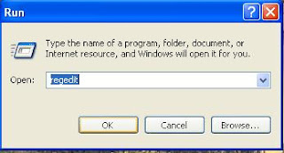](http://1.bp.blogspot.com/_c_oCoDXYEuc/S_zjdp8ytpI/AAAAAAAAAOA/PqwuhPJJ5QY/s1600/regedit.JPG)

**Step 2:**

In the registry editor navigate as per the following sequence:

*HKEY_LOCAL_MACHINE\System\CurrentControlSet\Control*

[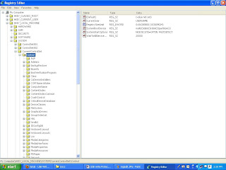](http://1.bp.blogspot.com/_c_oCoDXYEuc/S_zjpgbIg6I/AAAAAAAAAOE/2lOrmd3X_4g/s1600/registry.JPG)

**Step 3:**

Right click on Control, and make a new key by the name *StorageDevicePolicies*

[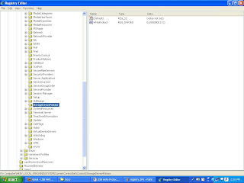](http://1.bp.blogspot.com/_c_oCoDXYEuc/S_zjvWrV_jI/AAAAAAAAAOI/fvB-DwIXbbI/s1600/storagedevicepolicies.JPG)

**Step 4:**

Now add a DWORD value to it by right clicking on the right side frame, and name that DWORD value as *WriteProtect*

**Step 5:**

Right Click on this newly created string and click modify. The default value is *0,*set it to *1*if you need to enable write protection.

[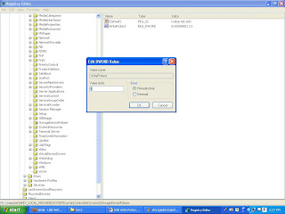](http://1.bp.blogspot.com/_c_oCoDXYEuc/S_zj2LnXbAI/AAAAAAAAAOM/FmhXfDYXZBQ/s1600/modify.JPG)

**Step 6:**

Reboot and check if it is working properly.

**End**